

**WEALTH AND STOCK PORTFOLIO OPTIMIZATION USING MONTE CARLO SIMULATION AND EXCEL SOLVER**

OSCM 6350 PRESCRIPTIVE ANALYTICS

ARAVIND THIRUNAVUKKARASU

R01470559

ABSTRACT

This project is a guide on how to manage and optimize your wealth and stock portfolio using Monte Carlo simulation and excel solver. The projects uses Excel solver to optimize your current stock portfolio by determining the perfect weightage of your investment to be invested into those stocks depending upon the average annual return rate and the standard deviation of the average annual return rate. We find the best possible annual return and standard deviation of the annual return using the excel solver method. Then we use Monte Carlo simulation to calculate the ending value for the next 30 years and simulate 1000 replications for the ending value of the 30 years. This average of the 1000 replications can give the average value of your wealth at the end of 30 years.

**TABLE OF CONTENTS:**

1. INTRODUCTION

2. BACKGROUND

3. SAMPLE DATA USED FOR ANALYSIS

4. DESCRIPTIONS OF METHODOLOGY

5. IMPLEMENTATION

6. COMPARISON OF RESULTS

7. FUTURE WORKS

8. CONCLUSIONS

9. REFLECTION ON LEARNING

10. REFERENCES

**INTRODUCTION**:

This project is a guide about using prescriptive and predictive analysis to optimize any investment portfolio to help individuals meet their financial goals and find the right age to retire. Financial planning is a major part of our lives and small steps to change our way of investing can earn high profits and reduce the age of retirement.

The average age of retirement is 62 years old and the average life expectancy is 69 years old according to the American census report, this means there is only 7 years that an average person enjoys their retired life. This means that an average person works almost 89% of their life just to enjoy 11% of their life. This projects gives us an insight on using basic prescriptive analysis to reduce the age of retirement to enjoy financial freedom after they retire.

The first and foremost way to financial freedom is to invest early, as any small investments at a person twenties can transform the magnitude of their wealth due to the power of compounding. The power of compounding multiplies your wealth and reduce the age of retirement.

Therefore the main goal of this project is to reduce the age of retirement by applying small changes to your investment portfolio.

**BACKGROUND**:

This project use Microsoft excel to do the Monte Carlo simulation and the Solver package to do the portfolio optimization.

This project can help determine

* The exact amount of investment into the individual stocks
* The amount to contribute each year to reduce your age of retirement
* The amount of withdrawal at the end of each year for the individual expenses incurred
* The specific age of retirement to attain your financial goals.

This project is dynamic and can change according to the users input to find each individual financial goals. This project can be also used as a template to input the data so that each individual meet their financial goals within retirement.

**SAMPLE DATA USED FOR ANALYSIS**:

A Stock portfolio comprising of 9 stocks are chosen for this analysis with individual average annual return rate and the standard deviation of the average annual return rate.

**Data used:**

|  |  |  |  |  |
| --- | --- | --- | --- | --- |
| Stocks |  | Percentage Invested | Average Annual return | STD of Average Annual return |
|  | Google | 25% | 25% | 10% |
|  | Affirm | 6% | 22% | 15% |
|  | Clevland Cliffs | 0.11% | 30% | 15% |
|  | JD.com | 6% | 10% | 5% |
|  | Micron | 11% | 20% | 16% |
|  | Facebook | 11% | 23% | 15% |
| Cryptos |  |  |  |  |
|  | Ethereum | 2% | 50% | 45% |
|  | Dodgecoin | 5% | 2% | 4% |
|  | Cardano | 34% | 23% | 50% |

Fig..3.1

For this project we have used an initial investment of $4696 which follows the above weightage.

The average annual return follows the pattern of historical data for the past 10 years. For stocks which do not have the historical data, the monthly return was taken and multiplied by 12 to convert them into annual return.

**DESCRIPTIONS OF METHODOLOGIES:**

We have used two methods for our analysis:

* Monte Carlo Simulation
* Excel Solver

**Monte Carlo Simulation:**

The Monte Carlo simulation method is stochastic (random sampling of inputs) method to solve a statistical problem, and a simulation is a virtual representation of the problem. The Monte Carlo simulation combines the two to give us a powerful tool that allows us to obtain a distribution (array) of results for any statistical problem with numerous inputs sampled over and over again.

The Monte Carlo simulation can be used in corporate finance, options pricing, and especially portfolio management and personal finance planning.

On the downside, the simulation is limited in that it can't account for bear markets, recessions, or any other kind of financial crisis that might impact potential results.

A Monte Carlo simulation can determine the size of the portfolio of a client that he would need in order to retire and effective manage reinvestment rates, asset class, diversification, tax rates, social security return and even possible lifespans.

**Excel solver:**

Solver is an add-in program in Microsoft excel which used what if analysis. Though simple it is a very effective tool. It consists of a objective cell that needs to be minimized, maximized or have a certain value. This is done by changing the decision variables and taking in account of the constrains. Excel solver can solve integer programing, linear programing by giving us optimized results. Excel solver also supports relational mathematical computations like greater than or equal to and so on…

Excel solver has numerous applications and it is very easy to learn. The limitations of excel solver is that it can compute only around 150 rows of the dataset and cannot do complex computations for a very large data set. For complex computation in a very large dataset, the GAMS software is used. The GAMS software can handle complex problem but it has a learning curve as it is quite difficult to write its mathematical equations in text without tagging cells like in excel. Therefore the excel solver is simple, easy and effective to handle normal linear and integer programming models to give us near optimized solutions.

**IMPLEMENTATION:**

**Monte Carlo method:**

The first and foremost step is to enlarge the data set by using Monte Carlo simulation for 30 replications. Let’s look at the data set in Fig…3.1, we have 9 stocks that has an average annual return and standard deviation of the average annual return. These 9 stocks should have 30 replications that follows the annual return and its standard deviation. The simulation replications should like the fig..5.1

The Monte Carlo simulation follows a normal distribution of mean and standard deviation in Fig…3.1, this is done by the formulae **=NORM.INV(RAND(),Mean,STD)**. The excel sheet when refreshed provides a new set of value following the mean and standard deviation of fig..3.1 each time.

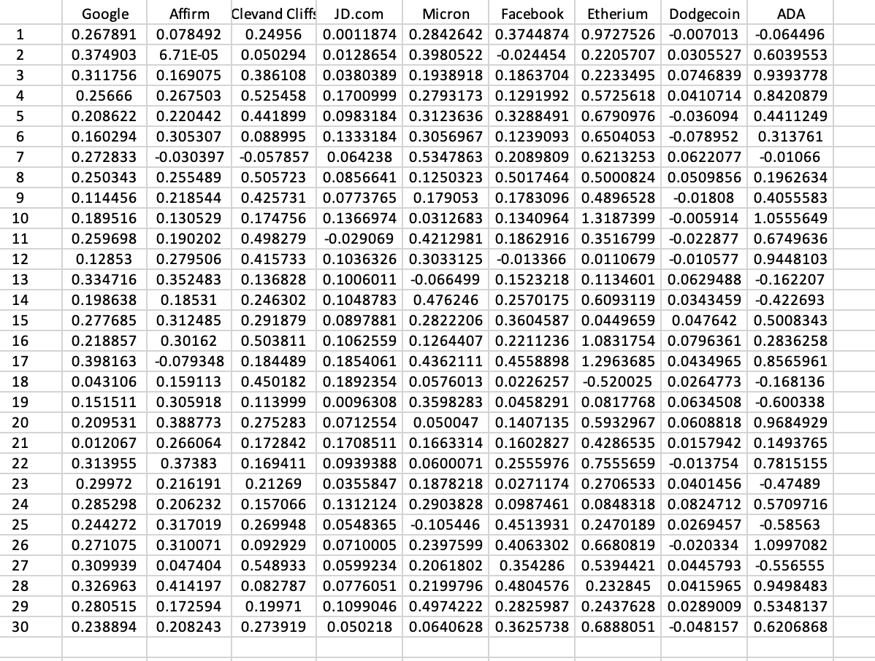Fig..5.1

The next step is that the weightage of the individual stock should be multiplied with its corresponding annual return rate. Then all the return rates for all the 9 stocks should be added for one single simulation replication, this should be repeated for all 30 simulation replications. The added final return rate should be multiplied with the investment value to get the final ending value of one year. The ending value of year one should be multiplied with the return rate of simulation two to get the ending value of year two and this process can be continued until 30 years for 30 simulation replications…Refer to fig…5.2 …This is also called compound interest method.

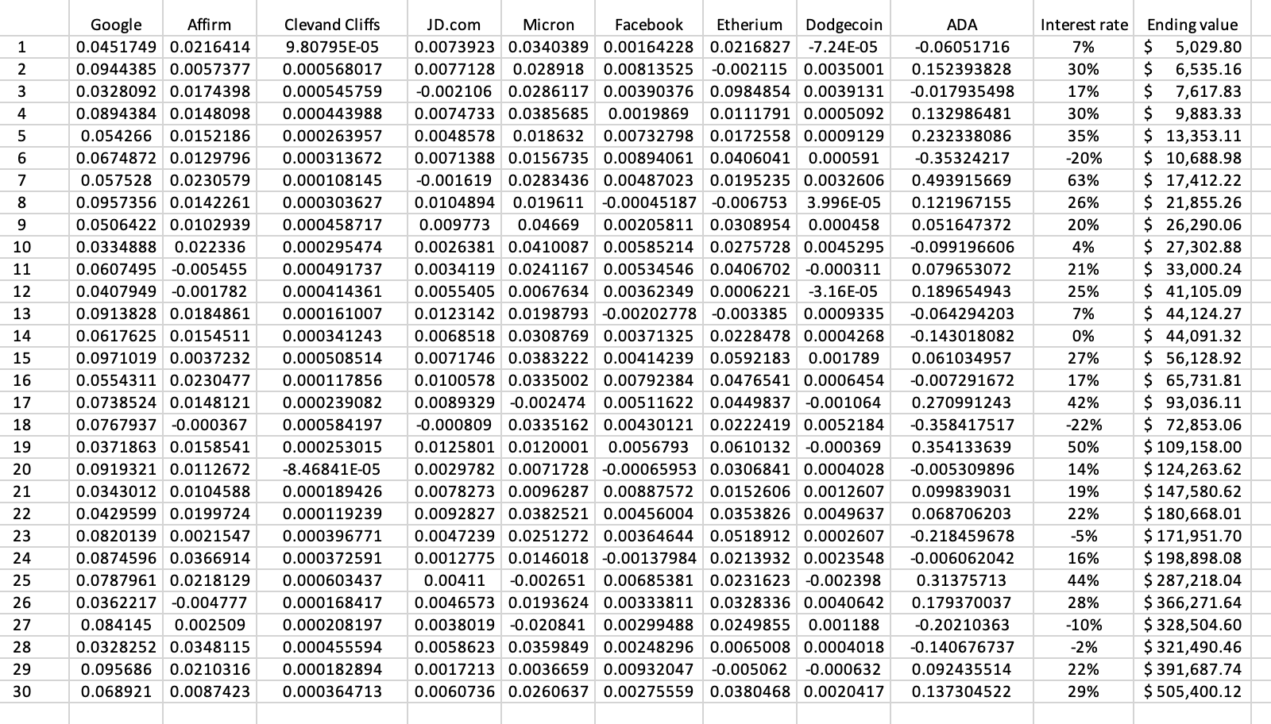

Fig..5.2

1000 simulation replications for the ending value of 30 years is taken using auto fill data table function in excel and the mean and standard deviation of the ending value is found from those 1000 simulation replications.

Thus, this mean and standard deviation considers all possible uncertainty and gives you the portfolio value after the end of 30 years. You can repeat this step for any ending year value to see your portfolio value at the end of that particular year and reach your financial goals sooner than expected.

**Excel solver method:**

Import the data in Fig..5.1 and find the covariance matrix of the imported data using the excel function =COVARIANCE.S(ARRAY1,ARRAY2). The covariance matrix should look like this in Fig..5.3

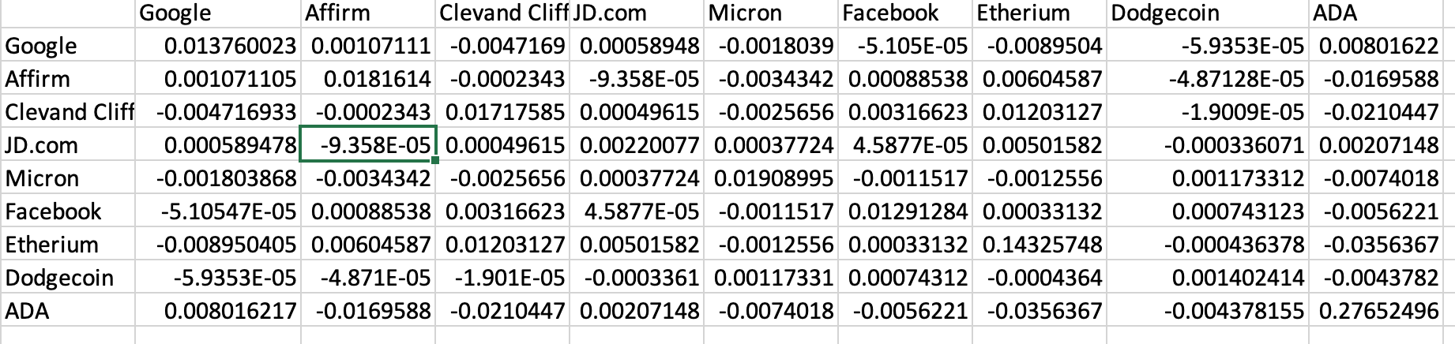

Fig…5.3

**Decision variable:**

We use excel solver on the fig…5.1 to determine the optimal weightage percentage of your investment to be invested in those stocks.

**Objective function:**

To maximize your Average Annual return rate.

The Average Annual return rate is the sum product of the decision variables and average return rate of the individual stocks in fig..5.1

**Constrains:**

Standard deviation should be less than or equal to 10%

Variance is the matrix multiplication of the decision variables and the covariance matrix in fig..5.3

Standard deviation is square root of variance

The above constrains or objective can be changed according to an individual preferences.

**COMPARISON OF RESULTS:**

The project compares the initial investment portfolio that is done by the individual and the final investment portfolio that is developed using excel solver and monte Carlo simulation.

Let’s take a look at the results and compare them…

**Initial Investment portfolio:**

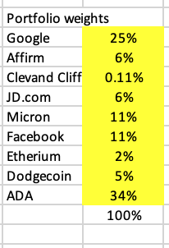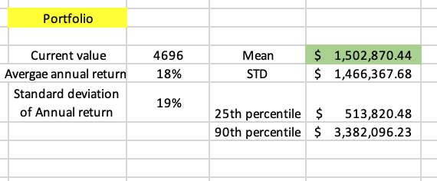

**The portfolio value after 30 years is around $1.5 million with an initial investment of $4696**

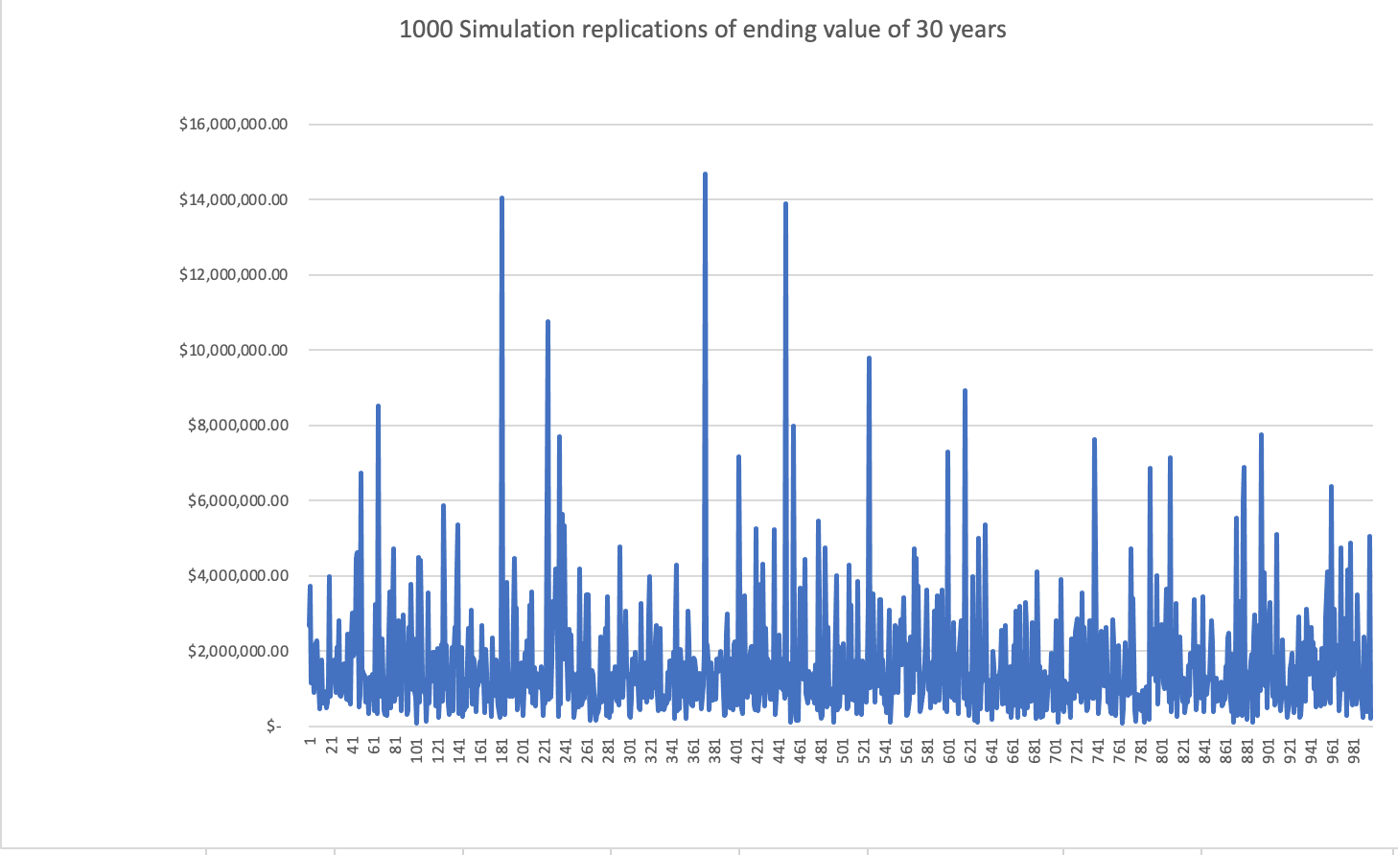

**Here you can see a lot of variations with the highest value being around $15 million**

**Final Investment Portfolio:**

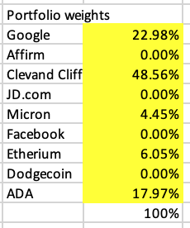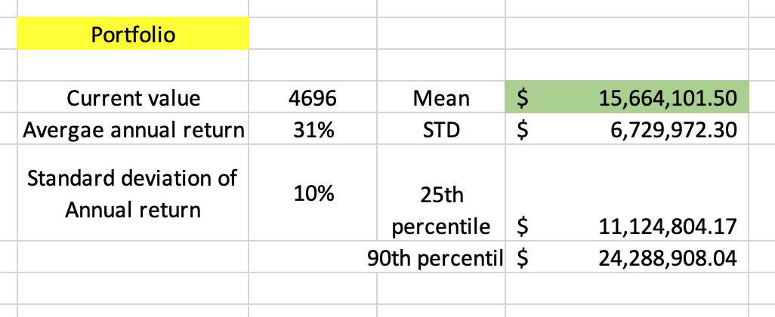

**The portfolio value after 30 years is around $15 million with an initial investment of $4696**

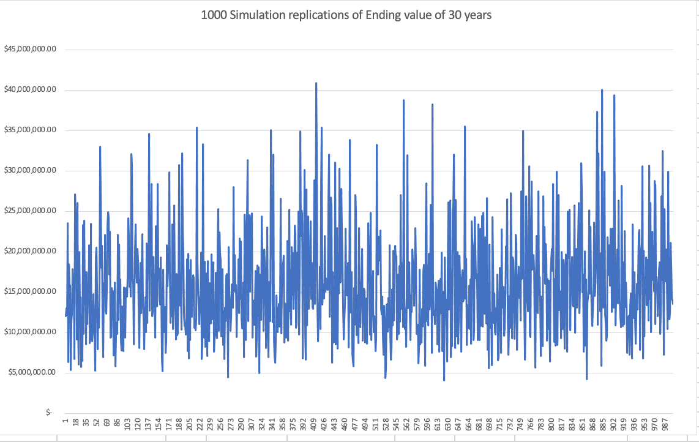

**Here you can see less variations with highest value of $41 million**

**Investment portfolio of S&P 500:**

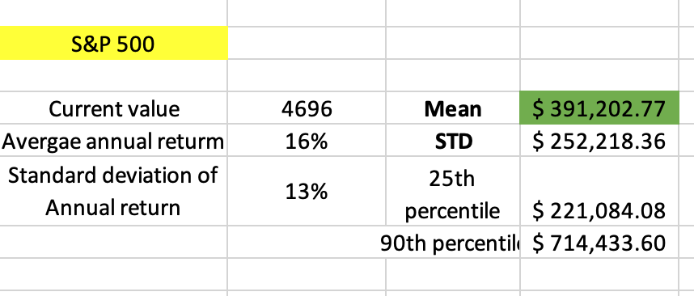

**The portfolio value after 30 years is around $391,203 with an initial investment of $4696**

**Investment portfolio of Vanguard Information Technology ETF:**

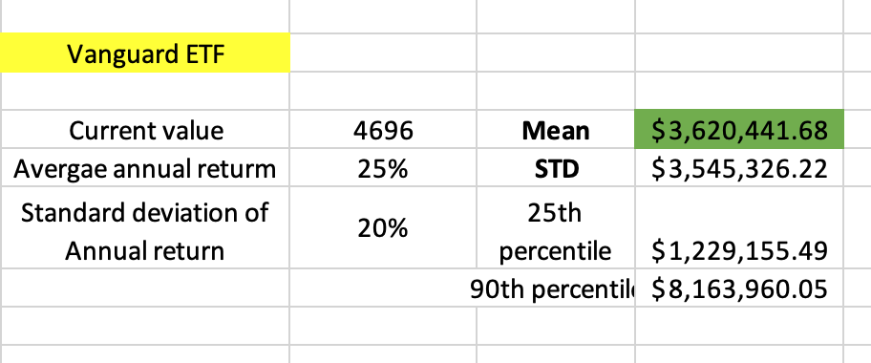

**The portfolio value after 30 years is around $3.6 million with an initial investment of $4696**

**COMPARISON OF ALL THE INVESTMENT PORTFOLIOS:**

|  |  |  |  |  |
| --- | --- | --- | --- | --- |
|  | **Initial Investment portfolio** | **Final Investment portfolio** | **S&P 500 Investment portfolio** | **Vanguard Information Technology ETF portfolio** |
| **Ending value after 30 years** | **$1.5 million** | **$15 million** | **$391,203** | **$3.6 million** |
| **Average Annual return** | **18%** | **31%** | **16%** | **25%** |
| **Standard deviation of Annual return** | **19%** | **10%** | **13%** | **20%** |

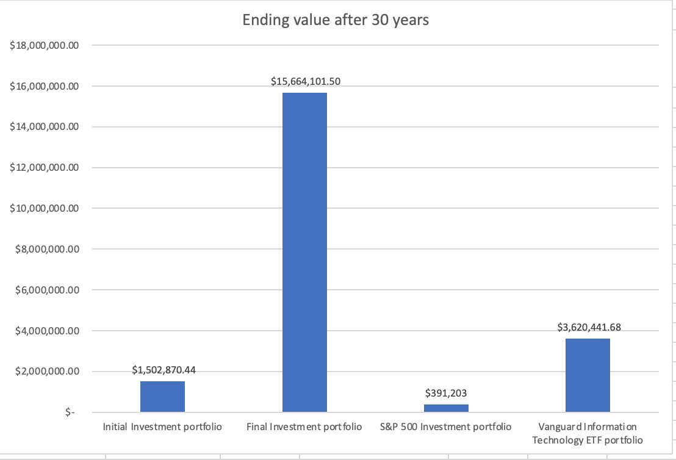

**FUTURE WORKS:**

This investment portfolio can be modified to take in recurring investment at the end of each year and can also accommodate withdrawals at the end of the each year. This recurring investment are just added with the ending value of each year and withdrawals are subtracted at the end of each year to get a more dynamic investment portfolio. To get the maximum investment at the end of X years, it is recommended to make minimum withdrawals and maximize recurring investment the end of each year.

Since this a small sample data set, excel solver can be used to get optimized weightage of investment. If a large data set is given, GAMS software can be used to find the optimized weightage of the stocks as it is equipped to handle large data set with maximum possibilities.

**CONCLUSION:**

This project has given us an insight on how small changes in investment methods can double up your investment portfolio up to 10 times or more. This project is just a mimic of the stock market and it is based on historical values and real life data can have huge downfall like bear markets, financial crisis in 2008, recessions and more. The historical data has shown us even after any bear market or recessions, the stock market always comes up stronger yielding higher returns.

The stocks market is always successful for long term investors with a minimum of 5 years and we have seen the jump in stock prices after any major recessions like 2008 financial crisis or corona virus pandemic.

**REFLECTION ON LEARNING:**

Smart and patient investment goes a long way and can help you achieve your financial goals.

The best way to achieve your financial goals is putting you money to work, rather than working hard and not investing. Hope this project gives you an insight on achieving your financial goals and financial independence.

**REFERENCES:**

<https://www.investopedia.com/articles/investing/112514/monte-carlo-simulation-basics.asp>

<https://fabianmoa.medium.com/monte-carlo-simulation-for-wealth-planning-in-excel-409659da262b>

<https://alphabench.com/data/excel-portfolio-optimization.html>